Unit 8: Trigonometric Functions (9 days + 1 jazz day + 1 summative evaluation day)

BIG Ideas:

Students will:
- Investigate periodic functions with and without technology.
- Study of the properties of periodic functions
- Study of the transformations of the graph of the sine function
- Solve real-world applications using sinusoidal data, graphs or equations

DAY | Lesson Title & Description | 2P | 2D | Expectations |  | Teaching/Assessment Notes and Curriculum Sample Problems
1,2 | Investigating Periodic Behaviour  - Complete investigations to collect data  - Follow-up with questions regarding cycle, amplitude and period, etc – without formally identifying them as such.  Lesson Included | N | N | TF3.01  ü | collect data that can be modelled as a sine function (e.g., voltage in an AC circuit, sound waves), through investigation with and without technology, from primary sources, using a variety of tools (e.g., concrete materials; measurement tools such as motion sensors), or from secondary sources (e.g.,websites such as Statistics Canada, E-STAT), and graph the data | 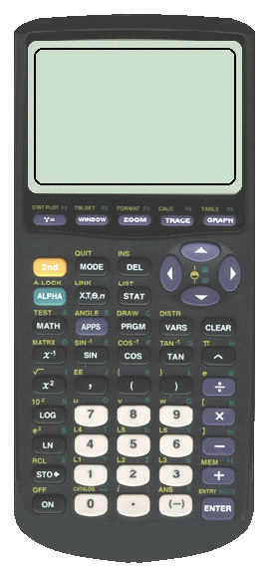 + CBL  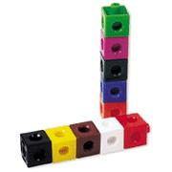
1,2 |  | N | N | TF2.01 | describe key properties (e.g., cycle, amplitude, period) of periodic functions arising from real-world applications (e.g., natural gas consumption in Ontario, tides in the Bay of Fundy), given a numerical or graphical representation;
3 | Introduction to Periodic Terminology  - Discuss definitions of cycle, period, amplitude, axis of the curve, domain and range | N | N | TF2.02  ü | predict, by extrapolating, the future behaviour of a relationship modelled using a numeric or graphical representation of a periodic function (e.g., predicting hours of daylight on a particular date from previous measurements; predicting natural-gas consumption in Ontario from previous consumption);
4 | Back and Forth and Round and Round  - Investigation to discover the effect variations have on the graph of a periodic function  Lesson Included | N | N | TF2.05  ü | make connections, through investigation with technology, between changes in a real-world situation that can be modelled using a periodic function and transformations of the corresponding graph (e.g., investigating the connection between variables for a swimmer swimming lengths of a pool and transformations of the graph of distance from the starting point versus time) | + CBL
5 | Introduction to the Sine Function  - Student led investigation to discover the Sine Function  Lesson Included | N | N | TF2.03  ü | make connections between the sine ratio and the sine function by graphing the relationship between angles from 0º to 360º and the corresponding sine ratios, with or without technology (e.g., by generating a table of values using a calculator; by unwrapping the unit circle), defining this relationship as the function f (x) = sinx, and explaining why it is a function; | Note: these students will not have seen trig ratios with angles greater than 90°
5 |  | N | N | TF2.04  þ | sketch the graph of f (x) = sinx for angle measures expressed in degrees, and determine and describe its key properties (i.e., cycle, domain, range, intercepts, amplitude, period, maximum and minimum values, increasing/decreasing intervals);
6 | Discovering Sinusoidal Transformations  - Using Graphing Calculator, discover the effects of a, c and d on the graph of y=sinx | N | N | TF2.06 | determine, through investigation using technology, and describe the roles of the parameters a, c, and d in functions in the form f (x) = a sinx, f (x) = sinx + c, and f(x) = sin(x – d) in terms of transformations on the graph of f (x) = sinx with angles expressed in degrees (i.e., translations; reflections in the x-axis; vertical stretches and compressions);
7 | Graphing Sine Functions  - Sketch the graphs of a given transformed sine function  Pair share wrap-up activity included BLM8.7.1 | N | N | TF2.07  þ | sketch graphs of f (x) = a sinx, f (x) = sin x + c, and f(x) = sin(x – d) by applying transformations to the graph of f (x) = sinx, and state the domain and range of the transformed functions  (note: only 1 transformation at a time) | Sample problem: Transform the graph of f(x) = sinx to sketch the graphs of g(x) = –2sinx and h(x) = sin(x – 180°), and state the domain and range of each function
8 | Applications of Sinusoidal Functions  - Work on application problems  - Given a sine function graph the function using technology  - Use the graph to answer questions.  Lesson Included | N | N | TF3.03  þ | pose and solve problems based on applications involving a sine function by using a given graph or a graph generated with technology from its equation |  with projector & power point (not necessary)
 |  |  |  | TF3.02  ü | identify sine functions, including those that arise from real-world applications involving periodic phenomena, given various representations (i.e., tables of values, graphs, equations), and explain any restrictions that the context places on the domain and range;
TF2.02
ü
9 | What Goes Up Must Come Down  - Graph sinusoidal data and find the curve of best fit (using TI-83s calculators)  - Use the graph to answer questions about the graph  Lesson Included | N | N | TF3.02  ü |  | with projector & power point (not necessary)
TF3.03
þ
TF2.02
ü
10 | Review Day (Jazz Day)
11 | Summative Unit Evaluation

Unit 8: Day 1 & 2: Investigating Periodic Behaviour |  |  |  | Grade 11 U/C
Minds On: 10 |  | Description/Learning Goals  - Students investigate and explore properties of periodic functions using technology and manipulatives. |  | Materials  BLM 8.1.1  BLM 8.1.2  BLM 8.1.3  For equipment list, refer to BLM 8.1.1.  TICTOC and DAMPING progs.
Action: 120
Consolidate: 20
Total=150 min
Assessment
Opportunities
 | Minds On… | Whole Group → Guided Instruction  Describe the tasks to be completed at each of the 6 stations. The 6 stations are: Pendulum, Slinky, Paddle, Square, Rectangle, and Pentagon.  Individual → I know, I wonder, I learned  Before beginning the stations, students will complete the “I know, I wonder” parts of the KWL chart for general knowledge of periodic functions. They should draw on their experiences during the first unit.  Mathematical Process Focus: Reflecting (Students will reflect upon their prior learning to clarify their understanding.) |  | For more information on KWL charts, refer to the “Think Literacy – Mathematics, Grades 10-12” document, p. 52.  If you would like to add/change the stations, you could investigate “Stay Tuned” and “Lights Out” from “TI-Explorations – Real-World Math with the CBL System: Activities for the TI-83 and TI-83 Plus”. You could also add a triangle and a hexagon to the shapes used.  Note: TICTOC & DAMPING prog. instructions ask for CBLs – but these are not needed for the investigations included in this package.  If you have a large class, you may need to duplicate stations.  Copy 1 set of BLM 8.1.1 to be placed at the stations.  Copy BLM 8.1.2 for each student.
 | Action! | Groups of 3 →Exploration of Periodic Functions  Learning Skills (Teamwork/Initiative): Students work in groups of 3 to complete BLM 8.1.2. Observe students and make anecdotal comments.  Groups will rotate through the stations, completing the activity and accompanying BLM. Groups will spend 20 minutes at each station. They will complete 3 stations each of the two days.  Mathematical Process Focus: Connecting (Students will connect real-world application to periodic functions.)
 | Consolidate Debrief | Whole Class → Discussion  Have the students post their chart paper and shapes from the square, rectangle, and pentagon stations. Discuss properties of the graphs developed at each of the stations, using the ideas of “what’s the same, what’s different?” You want to draw from the students the concepts of periodic functions, period, cycle, amplitude, phase shift, axis of the curve, without formally defining these terms.
Application  Reflection |  | Home Activity or Further Classroom Consolidation (Day 2)  Application: Students will work on questions related to periodic functions that do not require the formal definitions of period, amplitude, etc. Some examples can be found in Nelson, Mathematics 11, p. 408 – 414.  Reflection: I know, I wonder, I learned  Students will complete the “I learned” part of the KWL chart.

8.1.1 Investigating Periodic Behaviour

Slinky

Introduction to the Experiment:

In this investigation, you will use the CBR to collect motion data as a paper plate, attached to a loose spring oscillates (bounces) up and down above a motion detector. Then, you will analyze the results.

Equipment Needed:
- CBR
- TI-83 graphing calculator with a link cable and “DAMPING” program loaded
- slinky with paper plate attached

Performing the Experiment:
  - Connect the calculator to the CBR.
  - Make sure the program “DAMPING” has been loaded on your calculator.
  - Place the CBR on the floor with the motion sensor facing up.
  - Have a student stand beside the motion detector and hold the compressed slinky high above the CBR.
  - Run the program “DAMPING” and follow the instructions on the calculator.
  - When indicated by the program, let the slinky bob above the detector. Be sure that the pie plate does not come closer than 50 cm to the CBR at any time during the data collecting process.
  - You may wish to repeat the experiment until you are satisfied with your graph.
  - Answer the questions on your “Observations” handout.

8.1.1 Investigating Periodic Behaviour (continued)

Pendulum

Introduction to the Experiment:

In this experiment you are going to investigate the swinging of a pendulum. You will swing a pendulum back and forth so that it is always in the line of sight of the CBR. The CBR will measure the pendulum’s distance from the motion detector over regular time intervals. A distance vs. time graph will be plotted.

Equipment Needed:
- CBR
- TI-83 graphing calculator with a link cable and “TICTOC” program loaded
- pendulum - string, a large object to swing (e.g. pop can, or juice jug, a bucket), metre stick, retort stand
- clock with a second hand or stop watch

Performing the Experiment:

  - Connect the calculator to the CBR.
  - Make sure the program “TICTOC” has been loaded on the calculator.
  - Set up the pendulum and the CBR so that the motion detector is at the same level as the swinging object when at rest.

  - Position a metre stick along the table so that you can measure the distance from the motion detector to the pendulum.

  - Measure the distance between the pendulum and the CBR in cm. The distance must be at least 75 cm. Adjust your set-up as needed.
  - Determine how far you will pull the pendulum away from its original position. Record this information on your handout.
  - Use the stopwatch to determine the time it takes to complete 5 cycles. Record this information on your handout.
  - Run the program “TICTOC” and follow the instructions on your calculator.
  - You may wish to repeat the experiment until you are satisfied with your graph.

  - Answer the questions on your “Observations” handout.

8.1.1 Investigating Periodic Behaviour (continued)

Paddle

Introduction to the Experiment:

In this experiment you are going to investigate the swinging of a paddle. You will swing a paddle back and forth so that it is always in the line of sight of the CBR. The CBR will measure the paddle’s distance from the motion detector over regular time intervals. A distance vs. time graph will be plotted.

Equipment Needed:
- CBR
- TI-83 graphing calculator with a link cable and “TICTOC” program loaded
- ping pong paddle (a book could be used instead)

Performing the Experiment:

  - Connect the calculator to the CBR.
  - Make sure the program “TICTOC” has been loaded on your calculator.
  - Run the program “TICTOC” and follow the instructions on your calculator.

  - Hold the paddle a distance away from the motion detector so that when you swing it, it is in the CBR’s line of sight. Remember to keep the paddle more than 50 cm from the motion detector.

  - Start the program and swing the paddle back and forth. Try to make each swing as identical as possible.

  - You may wish to repeat the experiment until you are satisfied with your graph.

  - Answer the questions on your “Observations” handout.

8.1.1 Investigating Periodic Behaviour (continued)

Rolling a Square

Introduction to the Experiment:

In this experiment you are going to investigate the rolling of a geometric shape. You will cut out a square and poke a hole in the shape. With your pencil in the hole, “roll” the square along a straight edge at the bottom of your chart paper.

Equipment Needed:
- Chart paper
- Thick paper for the shape (ex. Bristol board)
- Markers
- Metre stick
- Pencils
- Scissors
- Tape

Performing the Experiment:

  - Cut a square out of the thick paper. Make sure your square has dimensions between 2 cm and 10 cm.
  - Using your pencil, poke two holes in your shape. Number each hole, hole 1 and hole 2.
  - Turn your chart paper so the longest side is horizontal. Using the metre stick and a marker, draw a straight line horizontally half of the way down the chart paper. Leave the metre stick on this line on the paper.
  - Place your pencil in hole 1 and roll your shape across the straight edge of the metre stick. Label this graph as “Square, hole 1”.
  - Using the same piece of paper and the metre stick, draw another line horizontally 5 cm from the bottom of the chart paper.
  - Place your pencil in hole 2 and roll your shape across the second straight edge. Label this graph as “Square, hole 2”.
  - Darken each graph with a different coloured marker. Tape your shape to your chart paper.

  - Answer the questions on your “Observations” handout.

8.1.1 Investigating Periodic Behaviour (continued)

Rolling a Rectangle

Introduction to the Experiment:

In this experiment you are going to investigate the rolling of a geometric shape. You will cut out a rectangle and poke a hole in the shape. With your pencil in the “hole”, roll the rectangle along a straight edge at the bottom of your chart paper.

Equipment Needed:
- Chart paper
- Thick paper for the shape (ex. Bristol board)
- Markers
- Metre stick
- Pencils
- Scissors
- Tape

Performing the Experiment:

  - Cut a rectangle out of the thick paper. Make sure your rectangle has dimensions between 2 cm and 10 cm.
  - Using your pencil, poke two holes in your shape. Number each hole, hole 1 and hole 2.
  - Turn your chart paper so the longest side is horizontal. Using the metre stick and a marker, draw a straight line horizontally half of the way down the chart paper. Leave the metre stick on this line on the paper.
  - Place your pencil in hole 1 and roll your shape across the straight edge of the metre stick. Label this graph as “Rectangle, hole 1”.
  - Using the same piece of paper and the metre stick, draw another line horizontally 5 cm from the bottom of the chart paper.
  - Place your pencil in hole 2 and roll your shape across the second straight edge. Label this graph as “Rectangle, hole 2”.
  - Darken each graph with a different coloured marker. Tape your shape to your chart paper.

  - Answer the questions on your “Observations” handout.

8.1.1 Investigating Periodic Behaviour (continued)

Rolling a Pentagon

Introduction to the Experiment:

In this experiment you are going to investigate the rolling of a geometric shape. You will cut out a pentagon and poke a hole in the shape. With your pencil in the hole, “roll” the pentagon along a straight edge at the bottom of your chart paper.

Equipment Needed:
- Chart paper
- Thick paper for the shape (ex. Bristol board)
- Template for pentagon
- Markers
- Metre stick
- Pencils
- Scissors
- Tape

Performing the Experiment:

  - Cut a pentagon out of the thick paper. Make sure your pentagon has dimensions between 2 cm and 10 cm.
  - Using your pencil, poke two holes in your shape. Number each hole, hole 1 and hole 2.
  - Turn your chart paper so the longest side is horizontal. Using the metre stick and a marker, draw a straight line horizontally half of the way down the chart paper. Leave the metre stick on this line on the paper.
  - Place your pencil in hole 1 and roll your shape across the straight edge of the metre stick. Label this graph as “Pentagon, hole 1”.
  - Using the same piece of paper and the metre stick, draw another line horizontally 5 cm from the bottom of the chart paper.
  - Place your pencil in hole 2 and roll your shape across the second straight edge. Label this graph as “Pentagon, hole 2”.
  - Darken each graph with a different coloured marker. Tape your shape to your chart paper.

  - Answer the questions on your “Observations” handout.

8.1.2 Periodic Behaviour - Observations

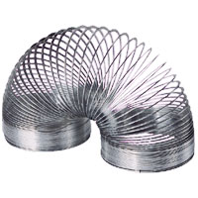
For each station, record your findings in the space provided.

Slinky

1) Record your graph in the box.

2) Use your TRACE key to determine:

The highest point: ________________

The lowest point: ________________

The y-intercept: __________________

The distance between the tops of two

consecutive “bumps”: _____________

3) How would the graph be different if you started collecting data when the paper plate is at its lowest point?

4) What is the range of your graph?

5) How long does it take for the slinky to return to its starting position?

8.1.2 Periodic Behaviour – Observations (continued)

Pendulum

1) The distance from the motion detector to the pendulum: __________ cm

The distance the pendulum is pulled back from its rest position: __________ cm

The time required for 5 complete cycles of the pendulum: __________ s

2) Record your graph in the box.

3) Use your TRACE key to determine:

The highest point: ________________

The lowest point: ________________

The y-intercept: __________________

The distance between the tops of two

consecutive “bumps”: _____________

4) How long does it take for the pendulum to swing through one complete cycle?

5) What is the pendulum’s average distance from the motion detector?

8.1.2 Periodic Behaviour – Observations (continued)
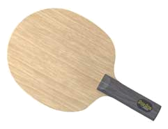

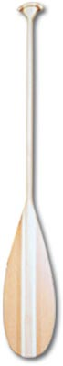
Paddle

1) Record your graph in the box.

2) Use your TRACE key to determine:

The highest point: ________________

The lowest point: ________________

The y-intercept: __________________

The distance between the tops of two

consecutive “bumps”: _____________

3) How can you change the distance between the tops of two consecutive “bumps” on your graph?

4) How can you change the y-intercept of your graph?

5) How can you change the vertical height of the graph (how tall the graph is)?

6) How can you make a graph that is the same shape as your original graph, but appears higher on the graphing calculator?

8.1.2 Periodic Behaviour – Observations (continued)

Square

1) How does the location of the hole selected affect the graph?

2) How would the graph be different if your hole was in the same position on a smaller square?

3) How would the graph be different if your hole was in the same position on a larger square?

Rectangle

1) How does the location of the hole selected affect the graph?

2) How would the graph be different if your hole was in the same position on a smaller rectangle?

3) How would the graph be different if your hole was in the same position on a larger rectangle?

8.1.2 Periodic Behaviour – Observations (continued)

Pentagon

1) How does the location of the hole selected affect the graph?

2) How would the graph be different if your hole was in the same position on a smaller pentagon?

3) How would the graph be different if your hole was in the same position on a larger pentagon?

After you have completed all 3 shapes, answer the following questions.

1) What similarities exist between the 6 graphs?

2) What differences exist between graphs constructed using the same shape? Using a different shape?

3) What could a graph generated by an octagon look like?

4) What could a graph generated by a circle look like?

5) If you wanted to make a graph with larger ‘waves’, what changes would you need to make to your shape?

8.1.3 Templates for Pentagons and Hexagons

8.1.3 Templates for Pentagons and Hexagons (continued)

8.1.4 Investigating Periodic Behaviour (Teacher Notes)

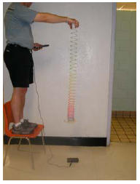
Slinky Demonstration:

Pendulum Demonstration:
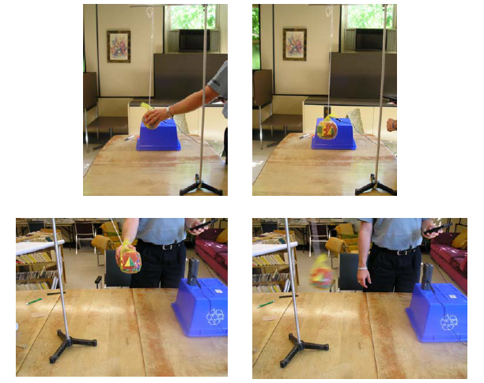

Note: The instructions given on the students handouts use the programs TICTOC and DAMPING. Alternatively you may also do these investigations using the RANGER program and choose Application from the Ranger Menu and then choose the Ball Bounce Application.

8.1.4 Investigating Periodic Behaviour (Teacher Notes)

Rolling a Rectangle demonstration:

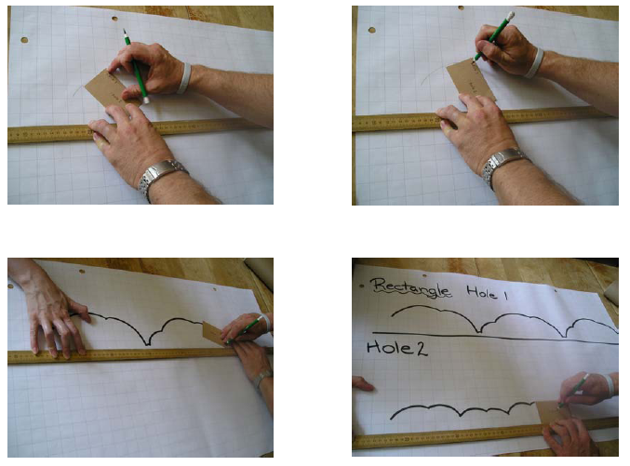

Note: The templates given in BLM 8.1.3 for the pentagons and hexagons are not necessary for any of the activities. Having students make their own, and allowing for irregular n-gons could make for a more rich discussion afterwards.

Unit 8: Day 4: Back and Forth and Round and Round |  |  |  | Grade 11 U/C
Minds On: 10 |  | Description/Learning Goals  - make connections between changes in a real-world situation that can be modelled using a periodic function and transformations of the corresponding graphs |  | Materials  - CBR  - Graphing calc. with view screen  - Hula-hoop  - Pendulum  - BLM 8.4.1, BLM 8.4.2, BLM 8.4.3, BLM 8.4.4
Action: 55
Consolidate: 10
Total=75 min
Assessment
Opportunities
 | Minds On… | Small Groups→Placemat  Learning Skills (Teamwork): Students work in groups to complete the placemat.  In groups of four, students individually complete their section of the placemat, responding to the statement: “Think about and then write down everything you can recall about periodic functions.”  Students take turns sharing their ideas, and then the group comes to a consensus to record a group response in the centre of the placemat.  Mathematical Process Focus: Reflecting (Students will reflect upon their prior learning to clarify their understanding.) |  | Circulate and help students to remember terms like cycle, period, amplitude, domain, range, etc.
 | Action! | Whole Class→Four Corners  Complete an investigation of real-world situations that illustrate changing period, amplitude, phase shift and axis in periodic functions.  Refer to Pendulum activity in Teacher’s Notes 8.4.1  Small Groups→Think, Pair, Share  Refer to Hula-Hoop activity in Teacher’s Notes 8.4.1.  Learning Skills (Teamwork): Observe students working in pairs/groups and make anecdotal comments.  Mathematical Process Focus: Connecting, Communicating (Students will connect real-life situations to different graphs and communicate their thinking to the whole class.)
 | Consolidate Debrief | Whole Class→Discussion  Select one member from each group to report on one of Harriet’s graphs.  Discuss results to correct any errors and/or clarify for students who have difficulty understanding.
Application  Concept Practice  Reflection |  | Home Activity or Further Classroom Consolidation  Complete BLM 8.4.4

8.4.1 Back and Forth and Round and Round (Teacher’s Notes)

Label the four corners of the room: “Period”, “Phase Shift”, “Amplitude” and “Axis”.

Pendulum

Set up a pendulum at the front of the room with the CBR approximately one metre away. A 2-litre pop bottle works well.

Create a periodic graph on the graphing calculator using the CBR and pendulum, with the pendulum starting approximately 40 cm from the vertical.
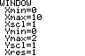
Exit from the RANGER program, and use  to adjust the axes as shown:

Press  and students copy the graph onto BLM8.4.1.

Ask how the graph will change if the pendulum starts at 40 cm from the vertical on the opposite side. (phase shift) Students respond by moving to one corner of the room, then briefly discuss within their groupings why they chose that corner. A representative from each group summarizes the discussion for the class.

Swing the pendulum from the opposite side to confirm/refute students’ hypotheses. Again, exit from RANGER, adjust the window settings and students copy the graph.

Repeat the activity with the following changes:
- Start the pendulum 20 cm from the vertical. (amplitude)
- Move the CBR further back and start the pendulum 40 cm from the vertical. (axis)
- Shorten or lengthen the length of the pendulum and start it 40 cm from the vertical. (period)

Hula-Hoop

Lay a hula-hoop on the floor approximately two metres from a wall. A student holds the CBR, pointed towards the wall and walks slowly around the hoop to create a periodic graph.

Students complete BLM 8.4.2 individually, and then compare answers with a partner. Two pairs join together to make a group of four to reach consensus and select a spokesperson to report to the whole class.

8.4.2 Back and Forth with a Pendulum

Copy the graph from each pendulum experiment into the screens below.

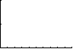
- Pendulum starts 40 cm from vertical.

- Pendulum starts 40 cm from vertical on opposite side.

- Pendulum starts 20 cm from vertical.

- CBR moves further away.

- Pendulum is .
^{Shorter/longer}

8.4.3 Round and Round with Harriet’s Hoop

Harriet walked around a hula-hoop and created the graph shown below.
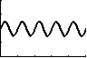

Each of the diagrams given below show Harriet’s original graph in bold together with a new graph. Describe the change(s) that Harriet would have to make in her walk to create each of the new graphs.

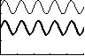

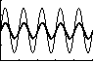

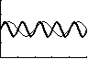
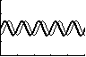

8.4.4 Back and Forth and Round and Round - Home Activity

Describe the motion that would be required to produce each of the following graphs.

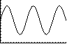
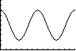
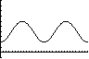

Unit 8: Day 5: Introduction to the Sine Function |  |  |  | Grade 11 U/C
Minds On: 10 |  | Description/Learning Goals  - Collect data that will be represented by a sinusoidal graph.  - Graph the data and draw a curve of best fit.  - Explore the properties of the sine function. |  | Materials  - BLM 8.5.1, 8.5.2, 8.5.3  - raw spaghetti (10 pieces per student)  - glue sticks  - protractors  raw
Action: 45
Consolidate: 20
Total=75 min
Assessment
Opportunities
 | Minds On… | Pairs→Think/Pair/Share  Learning Skills (Teamwork/Initiative): Students work in pairs to complete BLM 8.5.1.  Use students’ responses to discuss periodic functions with changes in amplitude, period, vertical shift and phase shift.  You may also wish to review some examples of right triangle trigonometry (SOH-CAH-TOA). |  | Ensure that students correctly measure and graph the heights at 0°, 180°, 360°, 540° and 720°.  Measurements below the water level should be glued below the axis.  You may need to complete the Observations section of BLM 8.5.2 together as a class.
 | Action! | Pairs→Investigation  Learning Skills (Work Habits): Observe students’ work habits and make anecdotal comments.  Copy the first two pages of BLM 8.5.2 for each student and the grid for each pair of students.  Students complete BLM 8.5.2.  Mathematical Process Focus: Connecting, Representing (Students will relate a periodic function to a real situation and will represent the function graphically.)
 | Consolidate Debrief | Whole Class→Discussion  Discuss the students’ graphs and the Observations questions.  Complete the “Key Properties” box together.
Application  Concept Practice  Reflection |  | Home Activity or Further Classroom Consolidation  Students answer questions like:  - How would the graph change if Freddy started at another position on the wheel (top, bottom, etc.)? What would be the same and what would be different?  - How would the graph change if the wheel rotated in the other direction?  - How would the graph change if the wheel were bigger/smaller?

8.5.1 Swimming Laps

Joachim is swimming lengths in his pool. His coach is standing at the side of the pool, halfway between the ends and recording his distance from Joachim. The graph of his progress is shown below:

The next day, Joachim swims in Juanita’s, pool. Her pool is shorter than Joachim’s.
t (s)

1. Which of the following graphs would represent his distance?
a)

b)

c)

- Beside each of the two remaining graphs, describe how Joachim would have to swim and where his coach would have to stand.


8.5.2 Freddy the Frog Riding a Mill Wheel

Freddy the frog is riding on the circumference of a mill wheel on a mini-putt course as it rotates counter-clockwise. He would like to know the relationship between the angle of rotation and his height above/below the surface of the water.

A scale diagram of the wheel is shown below. The actual wheel has a radius of 1 metre. Your task is to use dry spaghetti to help you determine the heights at various points around the circle.

Hypothesize
Draw a sketch of what you think the graph of angle vs. height above/below water level will look like.

Explore
- On the circle shown below, draw in spokes every 15°. The first one is done for you.
- Use the spaghetti to measure the height from the water level to the end of the first spoke. (Break the spaghetti at the appropriate height.) Be as accurate as possible.
- Glue the spaghetti piece onto the grid provided at the 15° mark.
- Repeat steps 2 and 3 for each spoke that you drew in step 1. You will need to do two complete rotations of the wheel (720°).
Break a piece of spaghetti to make this height

8.5.2 Freddy the Frog Riding a Mill Wheel (Continued)

Observations
- On your graph draw a smooth curve connecting the tips of the pieces of spaghetti.
- Describe the graph made by Freddy the Frog while travelling on the Mill Wheel. (Hint: Use some of the terminology you have learned over the last few days.)

1m
15°

- Given a diagram that is not to scale, describe another way to determine Freddy’s height when the wheel has rotated 15°. (Hint: ignore the wheel and focus on the triangle.)

- Determine Freddy’s height for each of the following angles using the method you described in #2.
a) 15° b) 30° c) 45° d) 60°

- Compare the answers you obtained in #4 with your spaghetti heights for the same angles. What do you notice?

- What name would you give to your graph?

Key Properties of f(x)= on the interval 0 x 360
°
°
≤
≤

Amplitude _______________ Period __________________ Intercepts ________________

Domain __________________ Max ________ Min ________ Range __________________

The graph is increasing when _________________________________________________

The graph is decreasing when _________________________________________________

Key Properties of f(x)= on the interval 0 x 360
°
°
≤
≤

8.5.2 Freddy the Frog Riding a Mill Wheel (Continued)

8.7.1 Sinusoidal Functions and Their Equations

Partner A: ____________________________ Partner B: ____________________________

Recall the graph of the function y = sin(x)

Write the equation for each relationship given below.

A coaches B | B coaches A
This sinusoidal function has a phase shift of 45° to the right. | This sinusoidal function has been vertically translated down 4 units

Discuss with your partner the characteristics of each graph given above. (E.g. Amplitude, period…)
Unit 8: Day 8: Applications of Periodic Functions |  |  |  | Grade 11 U/C
Minds On: 20 |  | Description/Learning Goals  - Predict, by extrapolating, the future behaviour of a relationship modelled using a numeric or graphical representation of a periodic function.  - Identify sine functions from real-world applications involving periodic phenomena, given various representations, and explain any restrictions that the context places on domain and range.  - Pose and solve problems based on applications involving a sine function by using a given graph or a graph generated with technology from its equation. |  | Materials  Large paper for placemat activity  Graphing calculators  BLM 8.8.1  BLM 8.8.2
Action: 30
Consolidate:25
Total=75 min
Assessment
Opportunities
 | Minds On… | Groups of 3 or 4 → Placemat  Review of concepts learned so far: Ask the students to “Take a few minutes to think about and then individually write down what you know about sinusoidal functions”. Students respond in a placemat activity.  Each group then shares one response with the class that is different from those already presented.  Have each group complete and post one (or more) of the key words from this unit on the word wall (inc. Amplitude, period, phase shift, vertical shift, domain, range, max, min, zeros) and/or complete the FRAME template (from unit #1) as a class for y = sinx |  | See page 69 of ‘Think Literacy  Grades 10 -12’ for the placemat sample, (which is exactly the concept to be discussed) and, page 12 for a Word Wall sample.  A graphic organizer /mind map is a useful technique to teach them how to set up a plan.  You will need to spend some time discussing the window settings using the problem context.  Refer to Presentation software file: Graphing_Sine_ Waves.ppt to walk students through solving the lesson problem using the Graphing Calculator.
 | Action! | Whole Class →Discussion  Pose the application question  The height above the ground of a rider on a Ferris wheel can be modelled by the sine function $h(x)=\text{25}\text{sin}(x−\text{90})\text{°+}\text{27}$ , where h(x) is the height, in metres, and x is the angle, in degrees, that the radius to the rider makes with the horizontal. Graph the function, using graphing technology in degree mode, and determine the maximum height of the rider, and the measures of the angle when the height of the rider is 40 m.  Guide the students as a whole class to plan a strategy for solving the problem.  Mathematical Process Focus: Selecting Tools and Computational Strategies (Students will select appropriate tools (e.g. graphing or scientific calculators) to solve application problems.)
 | Consolidate Debrief | Small Groups → Presentation  Class will work through 1st application question from BLM8.8.1 in small groups. Discuss solutions as a class.
Application  Concept Practice  Exploration  Skill Drill |  | Further Classroom Consolidation  Individual students will continue to solve the rest of (or some of) the questions from BLM8.8.1

8.8.1 Applications of Sinusoidal Functions

Graphing Calculator Instructions

To graph a sinusoidal function on the graphing calculator:
- Enter the equation using the □ screen.
- Adjust the window settings.
- Press .

To determine the solution to a question where a y-value is given:
- Press □ and enter Y2 = the y-value given.
- Press . There should be a graph of a sine curve and a graph of a straight line intersecting the sine curve.
- Determine the point of intersection, press  and move the cursor over where you think the point of intersection is. Then press  to get to the calc menu. Choose intersect and follow the directions on the screen (or press  three times).

Practice Questions
- Sunsets are later in the summer than in the winter. For planning a sunset dinner cruise through the 30,000 islands, the cruise planners may find the time, t, in hours (on a 24 hour clock) of the sunset on the nth day of the year using the equation $t=1\text{.}\text{75}\text{sin}(0\text{.}\text{986}n−\text{79}\text{.}\text{37})\text{°+}\text{18}\text{.}\text{43}$
  - This question does not have any x or y variables; however, you must use x and y when entering the equation into your graphing calculator. What equation will you enter into the calculator?
  - What are reasonable values for t in this situation?
  - What are reasonable values for n in this situation?
  - Graph the function. Remember to use your answers from b) and c) to change your window settings.
  - Determine the time of the sunset on Shera’s birthday of July 26, (the 207th day of the year).
  - On what day(s) of the year does the sun set the latest? What time is the sunset?
  - On what day(s) of the year does the sun set the earliest? What time is the sunset?
  - Determine the day(s) of the year when the sunset time is at 6:00 pm (18:00 hours).

- All towers and skyscrapers are designed to sway with the wind. When standing on the glass floor of the CN tower the equation of the horizontal sway is $y=\text{40}\text{sin}(\text{30}\text{.}\text{023}x)°$ , where y is the horizontal sway in centimetres and x is the time in seconds.
  - State the maximum value of sway and the time at which it occurs.
  - State the minimum value of sway and the time at which it occurs.
  - State the mean value of sway and the time at which it occurs.
  - Graph the equation. The window settings must be set using a domain of 0 to 12 and a range of -40 to 40.
  - If a guest arrives on the glass floor at time = 0, how far will the guest have swayed from the horizontal after 2.034 seconds?
  - If a guest arrives on the glass floor at time = 0, how many seconds will have elapsed before the guest has swayed 20 cm from the horizontal?

8.8.1 Applications of Sinusoidal Functions (continued)

- The average monthly temperature in a region of Australia is modelled by the function $T(m)=\text{23}\text{sin}(\text{30}m−\text{270})\text{°+}9$, where T is the temperature in degrees Celsius and m is the month of the year. For m = 0, the month is January.
  - State the range of the function.
  - Graph T(m) for 1 year.
  - In which month does the region reach its maximum temperature? Minimum?
  - If travellers wish to tour Australia when the temperature is below $\text{20}°$C, which months should be chosen for their tour?

- The population, F, of foxes in the region is modelled by the function $F(t)=\text{500}\text{sin}(\text{15}t)\text{°+}\text{1000}$, where t is the time in months.
  - Graph F(t). Adjust the window settings to show only one cycle. How many months does it take to complete one cycle?
  - State the maximum value and the month in which it occurs. State the minimum value and the month in which it occurs.
  - In which month(s) are there 1250 foxes? 750 foxes? Remember to specify the year as well as the month.
  - The population, R, of rabbits in the region is modelled by the function, $R(t)=\text{5000}\text{sin}(\text{15}t+\text{90})\text{°+}\text{10000}$. Graph R as Y2 on the same screen. Adjust the window settings for y to allow both curves to appear on the screen by setting Ymin to 500 and Ymax to 15000.
  - State the maximum value and the month in which it occurs for the rabbits, then the minimum value and the month in which it occurs for the rabbits and complete the chart.
 | Month for Max | Max Value | Month for Min | Min Value | Month for Mean | Mean Value
Fox
Rabbit

  - Describe the relationships between the maximum, minimum and mean points of the two curves in terms of the lifestyles of the rabbits and foxes and list possible causes for the relationships.

8.8.2 Graphing Sine Waves PowerPoint Presentation File (Teacher)

(Graphing_Sine_Waves.ppt)

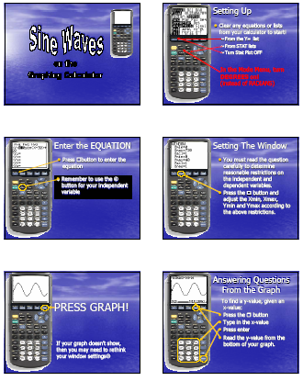

8.8.2 Graphing Sine Waves PowerPoint Presentation File (Teacher)

(continued)

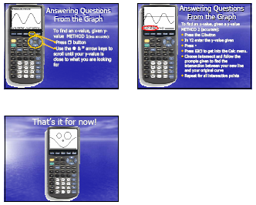
Unit 8 : Day 9 : Applications of Trigonometric Functions |  |  |  | Grade 11 U/C
Minds On: 10 |  | Description/Learning Goals  - Students will apply their understanding of trigonometric functions to various sets of data from real-world applications  - Students will use the graphing calculator to graph the data and develop a sinusoidal curve of best fit  - Students will use the curve of best fit to answer questions about the real-world application |  | Materials  - BLM 8.9.1  - BLM 8.9.2  - BLM 8.9.3  - Graphing calculators
Action: 30
Consolidate:35
Total=75 min
Assessment
Opportunities
 | Minds On… | Whole Class → Discussion  As a class, discuss homework from yesterday. In particular, focus on question #4, if assigned. |  | When determining the curve of best fit, using the TI-83, the calculator must be in radian mode. (Note that radian measure is not an expectation of this course, but is necessary for TI regressions)  A review of entering data into the TI-83 and sine regression, refer to the presentation file  Fitting_periodic_data.ppt  Note: for BLM 8.9.2 question #2, the amplitude of the curve increases as the location moves farther away from the equator.  For more data go to: www.hia-iha.nrc-cnrc.gc.ca/sunrise_adv_e.html.  For locations: http://worldatlas.com/aatlas/imageg.htm  Or www.confluence.org/search.php  Or your gas bill
 | Action! | Small Groups → Investigation  Using real-world data, graph the data, use the graphing calculator to determine the curve of best fit, and answer questions about the graph.  Students will work through BLM 8.9.1 in groups of 2 or 3.  Learning Skills(Teamwork/Initiative): Students work in groups of 2 or 3 to complete BLM 8.9.1.  Mathematical Process Focus: Connecting (Students will make connections between different representations of trigonometric functions, e.g. table of values, graph, equation and students will relate mathematical ideas to situations or phenomenon drawn from other contexts.)
 | Consolidate Debrief | Whole Class → Discussion  Discuss the students’ answers to BLM 8.9.1.
Application  Concept Practice |  | Home Activity or Further Classroom Consolidation  Students will work on BLM 8.9.2. The students will need graphing calculators to determine the equations. If necessary, they should be able to answer the questions without the graphing calculator by drawing more than one cycle of the curve.

8.9.1 What goes up… must come down…

The table below shows the average monthly high temperature for one year in Kapuskasing.

Time (months) | Month Number | Avg Temp (°C) |  | Time (months) | Month Number | Avg Temp (°C)
January | 0 | –18.6 |  | July | 6 | 17.0
February | 1 | –16.3 |  | August | 7 | 15.4
March | 2 | –9.1 |  | September | 8 | 10.3
April | 3 | 0.4 |  | October | 9 | 4.4
May | 4 | 8.5 |  | November | 10 | –4.3
June | 5 | 13.8 |  | December | 11 | –14.8

- Draw a scatter plot of the data and the sketch a curve of best fit.



- What type of model best describes the graph? Explain your answer.

- What is the domain of the function you have drawn for the given data?

8.9.1 What goes up… must come down…

- What is the possible domain of this situation, if the data continued for many years?

- State the minimum and maximum values.

minimum = _________________ maximum = ________________

- What is the range of this function?

- Write an equation for the axis of the curve. ____________________________________

- Enter the data into the lists of your graphing calculator. Perform a sinusoidal regression and store the equation in Y₁.

- Go back to the graph. Compare the graph and the scatter plot. How ‘good a fit’ is the equation?

- Turn the scatter plot off, and use the graph to determine the average monthly temperature for the 38th month.

- Jim Carey wants to visit Kapuskasing. His favourite temperature is 12°C. When should he plan to go to Kapuskasing? Use your graph to determine your answer.

8.9.2 Successfully Surfing into the Sunset requires Practice!

Answer the following questions in your notebook. You will need graph paper for your graphs.

- The table below shows how the number of hours of daylight observed at Trois-Rivières, Québec varies over several days. Trois-Rivières is located at 72º 33’ W and 46º 21’ N. Day 0 represents January 1st.

Day Number | # of hrs of daylight |  | Day Number | # of hrs of daylight
0 | 9.84 |  | 212 | 16.02
31 | 10.72 |  | 243 | 14.39
59 | 12.08 |  | 273 | 12.74
90 | 13.79 |  | 304 | 11.15
120 | 15.45 |  | 334 | 10.03
151 | 16.79 |  | 365 | 9.82
181 | 17.04

  - Draw a scatter plot of the data and then sketch the curve of best fit.
  - What is the domain of the function you have drawn for the given data?
  - What is the possible domain for this situation, if the data continued for many days?
  - State the minimum and maximum values.
  - What is the range of this function?
  - Write an equation for the axis of the curve.
  - Enter the data into the lists of your graphing calculator. Perform a sinusoidal regression and store the equation in Y₁.
  - Turn the scatter plot off, and use the graph to answer the following question. On the next season of the Amazing Race, they want to run a detour in Trois-Rivières. The detour will require exactly 16 hours of daylight. When should they plan to have the teams arrive in Trois-Rivières? Express your answer(s) in terms of month, i.e. early January, mid February, late March, etc.

- Balmaceda, Chile is located at 72° 33’ W and 46° 21’ S. It is at the same latitude as Trois-Rivières, and is the same distance below the equator as Trois-Rivières is above the equator.

  - Describe the graph of the number of hours of daylight for Balmaceda, compared to the graph for Trois-Rivières that you made in question 1? What would be the same, what would be different?
  - The table below shows how the number of hours of daylight observed at Balmaceda varies over several days. Day 0 represents January 1st.

Day Number | # of hrs of daylight |  | Day Number | # of hrs of daylight
0 | 17.00 |  | 212 | 10.62
31 | 15.81 |  | 243 | 12.02
59 | 14.25 |  | 273 | 13.64
90 | 12.51 |  | 304 | 15.38
120 | 11.02 |  | 334 | 16.76
151 | 9.97 |  | 365 | 17.02
181 | 9.82

8.9.2 Successfully Surfing into the Sunset… (continued)

2) … continued
  - Draw a scatter plot of the data and sketch the curve of best fit.
  - What is the domain of the function you have drawn, for the given data?
  - What is the possible domain for this situation, if the data continued for many days?
  - State the minimum and maximum values.
  - What is the range of this function?
  - Write an equation for the axis of the curve.
  - Enter the data into the lists of your graphing calculator. Perform a sinusoidal regression and store the equation in Y₁.
  - Turn the scatter plot off, and use the graph to answer the following question. On the next season of the Amazing Race, they want to run another detour in Balmaceda. The detour will require the maximum number of hours of daylight possible. When should they plan to have the teams arrive in Balmaceda? Express your answer(s) in terms of month, i.e. early January, mid February, late March, etc.
  - Where would the next stop on the Amazing Race need to be located so that the graph of number of daylight hours observed would have a smaller amplitude than the graph of number of hours of daylight observed in Balmaceda?

- The table below shows how the time of sunset in Saskatoon varies over several days. The times are from a 24-hour clock, in hours. Day 0 represents January 1st.

Day Number | Time (hr) |  | Day Number | Time (hr)
0 | 16.9 |  | 172 | 21.5
65 | 18.3 |  | 236 | 20.2
80 | 19.2 |  | 264 | 19.2
130 | 20.8 |  | 355 | 17.0

  - Draw a scatter plot of the data and sketch the curve of best fit.
  - What is the domain of the function you have drawn, for the given data?
  - What is the range of this function?
  - What is the possible domain for this situation, if the data continued for many days?
  - State the minimum and maximum values.
  - Write an equation for the axis of the curve.
  - Enter the data into the lists of your graphing calculator. Perform a sinusoidal regression and store the equation in Y₁.
  - Turn the scatter plot off, and use the graph to answer the following question. Ms. Chilvers wants to travel to Saskatoon and see the sun set at 8:00 pm. When should she plan to go to Saskatoon? Express your answer(s) in terms of month, i.e. early January, mid February, late March, etc.

8.9.3 Fitting Periodic Data PowerPoint Presentation File (Teacher)

(Fitting_Periodic_Data.ppt)

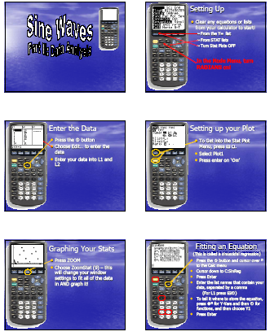

8.9.3 Fitting Periodic Data PowerPoint Presentation File (Teacher)

(Continued)



